MacDonald,William
W0248419
Practical 10: Web development

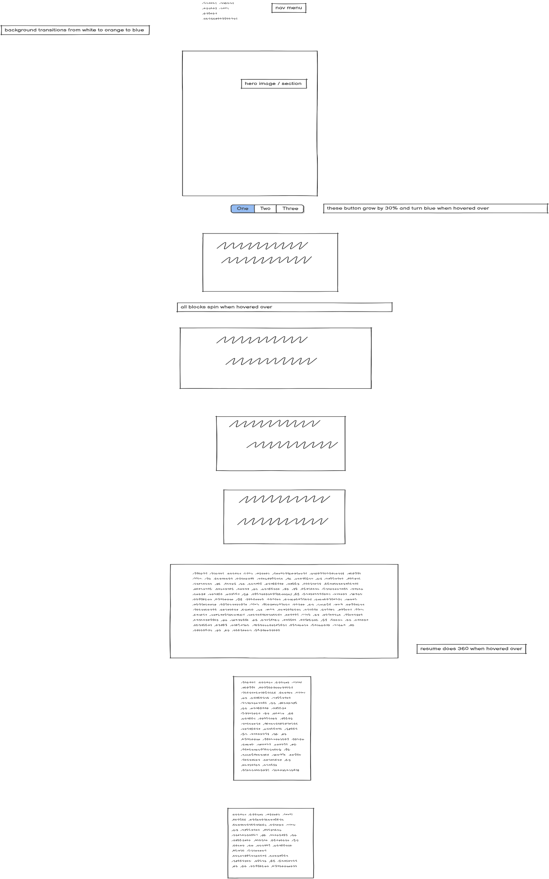

Summary of receive suggestions:
The suggestions I receive largely focused on 2 main areas the professionalism of the website, the look was a bit bland. I agree with these assessments and before the final intend on changing them by doing the following. To address the border around the hero image I am going to move the hero image to the top left of the page and put a body of text in the middle and the nav menu on the right, hopefully making things look better but also taking away the need to highlight the hero image.

I will change the spinning animations on the H2’s to a more simplified and less in your face animation like growing slightly when you hover over them. And will add a few more animations to the website such possible a few colour changes and a banner on the top of the page that will act as a webpage title that may move slightly.

As for the final comment I think making most of the text short simple and spaced evenly or predictably around the webpage will make for a more cohesive design which I believe is what Ryan was trying to point out about the site.

COMMENTS RECEIVED
Comment from: | Comment | Accept/Reject | Rationale
Morgan | The spinning is a bit to much | accept | Needs more professional animation that makes the user experience better.
Ryan | Consistent on capitalization. | Accept | Consistency is key / looks better. Needs to look more professional
Bolu | Border around hero image | Accept | Will help the image standout. Hero image looks goo in place but clashes with the rest of the site.

COMMENTS GIVEN
Comment made to: | Comment:
Morgan | Colors need to be a bit more uniform  The colors take away from the good bones of the site and are a bit distracting especially when you use it to change from mobile view to desktop view.
Bolu | Could use more text on the main page and the color change when hovering over main page is distracting.  The main landing page is just a bit boring it looks professional, but nothing grabs you right away.
Ryan | The CTA header shouldn’t be in a box, the CTA seemed like it just stood out from the website it’s self and could fit more cohesively

